December 2025 Newsletter- 
Relational mentoring Scotland
Funded by the Scottish Government
Welcome! December 2025

I hope you all had a lovely festive period. We continued to support families across Scotland with mentoring and energy help in Inverclyde, Renfrewshire, Glasgow, North and South Lanarkshire and the Scottish Borders.
We partnered up with the Glasgow Times ‘Bank on Us Campaign’ again and delivered toys, toiletries and food parcels to families in need in the run up to Christmas.

For Relational Mentoring support use this link:
One to one tailored mentoring and support

Currently we have no waiting lists in every locality, and your customers are being contacted the next working day after referral.
You can also use the above link to ask for FEEDBACK on your customers.

Don’t forget we have HEAT energy services available for anyone who pays a bill across Scotland. You can refer using this link HEAT
Please, as always, reach out if you need any other information and/or would like us to attend any events you have coming up.


Heather Coulthard Ann Nye
Email Heather Email Anne

Relational mentoring good news story – from Julia
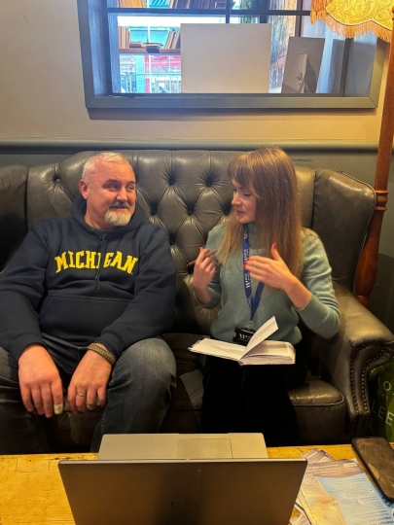

Sometimes the hardest step towards your goal is simply believing that you can achieve it, even when everything seems against you, and your own doubts feel louder than anyone else’s encouragement. S’s story is a perfect example of how persistence, support, and a little guidance can change a life.
I first met my customer, S earlier this year. His dream was simple but deeply meaningful – to find a job and be a reliable support for his family.
On paper, it seemed like he had everything going for him – rich and diverse experience, fluency in four languages, and he was studying at Glasgow Clyde College. However, he didn’t believe in himself. English felt like a wall he couldn’t climb, and every small setback made him doubt that he could succeed. It quickly became clear that Stanislav needed more than language support – he needed someone to believe in him when he couldn’t.
The first hurdle came with his UKVI account. Due to a technical glitch S ended up with two separate accounts he couldn’t manage. He hadn’t realised the issue himself, and it was impossible for him to fix it alone. Within a week, I worked with the Home Office support team to resolve the problem and secure his electronic visa. It was a small victory, but for my client, it was the first real taste of progress – and a reminder that solutions do exist when someone helps navigate the system.

S threw himself into every opportunity. He studied English every day, attended extra weekend classes, and juggled three volunteer roles during the week. Over the summer, my colleague Stephanie and I helped him prepare for work: CVs, cover letters, and interview practice. Not every interview went perfectly – far from it – but each one became a chance to learn. And when S felt like giving up, I would find a new opportunity for him.
One day, I came across a maintenance operative vacancy on Indeed that I thought would suit him perfectly. He applied, and this time, everything clicked. S got the job at the Alexander Thomson hotel. It wasn’t just a win on paper – it was a victory over self-doubt, over the hurdles of learning, and over all the moments he thought he couldn’t do it.

By early November, S had completed his probation and was fully part of the hotel team. He continues to study and work part-time and is set to move into a full-time role in May, after completing his college studies. Along the way, he has shown remarkable resilience –managing health challenges, studies, work, and volunteering, with steady support in navigating medical care and essential services, without ever losing his determination.
Today, S is happy, confident, and proud of what he has achieved. Most importantly, he is grateful for the people who believed in him when he couldn’t believe in himself. His story reminds us why our work matters: with guidance, encouragement, and persistence, even the most daunting obstacles can be overcome. And sometimes, all it takes is a little nudge at the right moment – and a good sense of humour – to keep going.

Partner feedback

Alan Ross, Community Link Worker NHS Lanarkshire – Heather, I was singing the praises of the great work that you all do and felt he would really benefit from input from the Wise Group and he was happy for me to make the referral.

I hope you and all the staff have a lovely Christmas and New Year and that you enjoy some well-deserved time off.

The Good Deed, Motherwell - Our second group has completed the food hygiene course — well done everyone!
A big thank-you to Ann Nye from the Wise Group for taking the time to come along and support the group.
Thank you also to the Wise Group for supporting families with electricity. gas and supermarket vouchers. Our community group is truly grateful for the help — it’s making a real difference.


Glasgow Times ‘Bank on us campaign’ delivering toys, food and toiletries to families in need.

Our RMS Christmas celebration !



More wins in collaboration with our heat service-
This case is a powerful reminder of what happens when the right support meets real-life need.
The customer came to HEAT from RMS while on a PAYG meter that simply wasn’t suitable for her household. With caring responsibilities, medical needs, and ongoing financial pressure, PAYG left her constantly topping up just to stay safe — with no room to breathe and no clear picture of what she actually owed.
That’s where HEAT stepped in.
Turning the Tide
Working directly with the supplier, the team successfully switched the customer from PAYG to a credit meter and ensured a suitable, affordable repayment plan was put in place — one that reflected her circumstances, not just the balance on the screen.
At the point of transition, there was a remaining PAYG balance that could have followed the customer and continued the cycle of stress. Instead, HEAT funding was used strategically:
- Clearing the PAYG balance in full
- Creating a financial cushion
- Allowing the remaining balance to be transferred to the new credit account in a manageable way
For the first time, the customer wasn’t starting from behind.
More Than Just a Meter Change
Alongside the technical work, HEAT ensured the wider picture was covered:
- The customer was placed on a better social tariff, reducing ongoing costs
- A foodbank referral was completed to support the household short-term
- A benefits check link was shared to explore longer-term financial support
- PSR needs were confirmed, keeping health and safety front and centre
Why This Matters
This Wise Win isn’t just about switching a meter — it’s about breaking the PAYG trap.
By removing an unsuitable payment method, clearing immediate debt, and setting up a realistic repayment plan, HEAT helped move this household from constant crisis to stability and control.
A Win for the Customer — and the Team 💙
This is the kind of work that often happens behind the scenes: supplier calls, funding decisions, careful timing, and advocacy that makes all the difference.
To peers across the team, this case is a reminder that our intervention doesn’t just reduce numbers — it changes outcomes.
From PAYG pressure to breathing space.

Our service leaflets for download -





HEAT - Home energy advice team
HEAT for anyone struggling with anything to do with energy for anyone who pays an energy bill.
- Energy crisis & advocacy support
- Energy saving awareness
- Income maximisation
- Energy efficiency Advice
- Debt management You can refer using this link HEAT


